|  |  |
| --- | --- |
| **Topic** | Android Project for Training |
| **Document Name** | Defibition of “Kalan Kullanımlarım” Application |
|  |  |

|  |  |  |  |
| --- | --- | --- | --- |
| **Document Difficulty Level** | | | |
| **Beginner** | **Junior** | **Senior** | **Expert** |
| □ | ■ | □ | □ |

# Document History

|  |  |  |  |
| --- | --- | --- | --- |
| Date | Author | Ver | Comments |
| 27.06.2017 | Ufuk Armağan Özgür | 1.0 | Initial Draft |

## Kalan Kullanımlarım Application

**Definiton**

Create an Android application that name is “Kalan Kullanımlarım”.

* Design a database in Oracle for record customer and customer usage informations.
* Database must consist of following datas;
* Phone number of customers.
* Password of customers.
* Personal information of customers.
* Tariffs of customers and this tariffs informations.
* Usage amount of customers.(voice , data , sms)
* Usage history month by month.
* Write a PL/SQL scripts that makes ;
* One of these scripts must return customer name, surname and tariff name according to phone number.
* An other one must return remaining usage rights.
* Last one must make password checking.
* Write a Web Service for get result of these PL/SQL scripts.
* Finally create an Android application that;
* There must be 3 activity: Login , İnformations about subscriber and Remain usages.
* User must login with his phone number and password on First activity.
* Then personal information and tariff name of user must shown on second activity.
* Finally remaining usages of this customer must be shown on last activity.

**Sample Outputs**

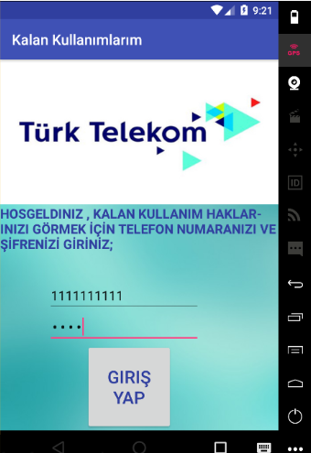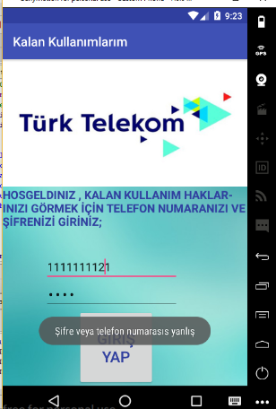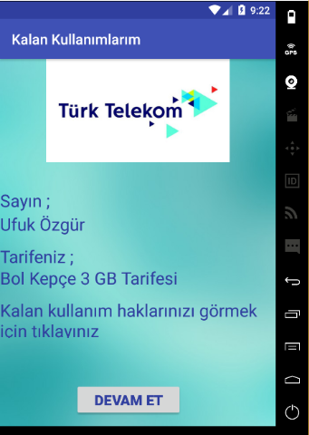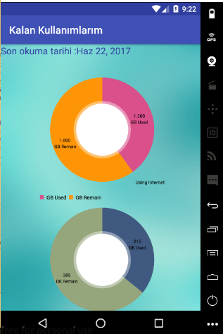

**Objectives**

* To learn create and design a database.
* To learn write PL/SQL scripts according the requirements.
* To learn write a Web Service and get datas from database using this Web Service.
* To learn get informations from PL/SQL scripts as a Json files.
* To learn make an Android application completely.
* To learn send json file from Web Service to Android Project.
* To learn parse a json file in Android Project.